**Big Mountain Resort Pricing and Facilities Optimization**

This report provides an analysis of Big Mountain Resort's pricing strategy and potential changes to its facilities, aiming to optimize revenue and visitor experience. Our data-driven recommendations are based on a wide comparison of Big Mountain Resort's features with those of other ski resorts in the market.

Based on our analysis, we propose the implementation of Scenario 2: increasing the vertical drop by 150 feet and installing an additional chair lift. Additionally, to reduce costs, the Resort may consider a temporary closure of the least popular runs.

**Key Findings:**

* Big Mountain Resort's current ticket price of $81.00 is lower than the predicted price of $95.87 based on the resort's facilities. This suggests potential room for increasing the ticket price, which could result in higher revenue. It is crucial to monitor visitor feedback and satisfaction to ensure that the new pricing strategy does not negatively affect the resort's reputation or visitor experience.

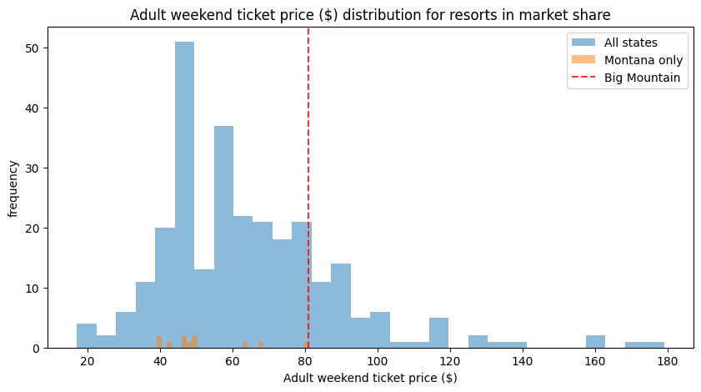

* The resort has several facilities that rank well in comparison to its competitors, such as vertical drop, snow-making area, total number of chairs, fast quads, number of runs, longest run length, and skiable terrain. These features contribute to the resort's ability to support a higher ticket price. Below is a comparison of Big Mountain Resort's most relevant features for our analysis: vertical drop, snow-making area, total chairs, and number of runs to other resorts in the market:

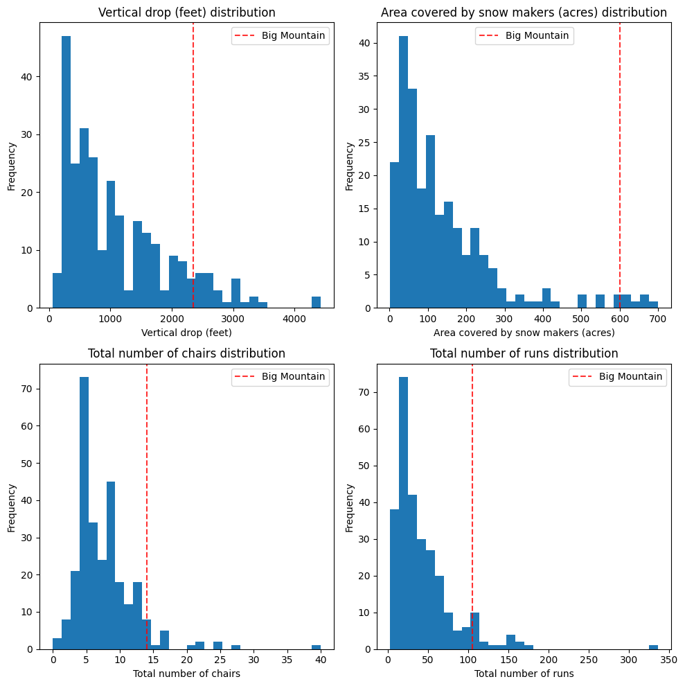

**Recommendations:**

1. Consider implementing Scenario 2: Increase the vertical drop by adding a run to a point 150 feet lower down, requiring the installation of an additional chair lift. Our analysis indicates that this option would not only cover the additional operating cost but also contribute to generating additional revenue of $1,934,638 for the resort. Visitor experience is expected to improve, making this investment worthwhile. We must monitor visitor feedback and satisfaction to ensure that the change meets expectations.
2. Evaluate run closures if a cost reduction is needed: If the resort decides to close some of its runs, consider closing 4 or 5, which supports a ticket price reduction of $1.26. However, this will result in an accompanying revenue decline of $2,206,521.

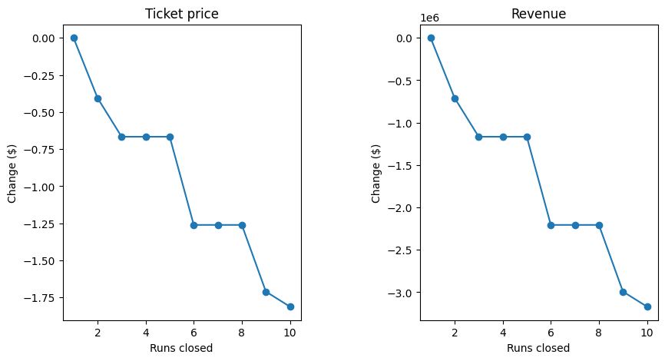

To make an informed decision on run closures, the resort should:

* 1. Conduct surveys or gather feedback from visitors to understand the impact of the closures on their experience.
  2. Analyse historical usage data to identify the least popular or least profitable runs.
  3. Implement temporary closures to evaluate the impact on visitor satisfaction, resort operations, and overall revenue.

1. To further optimize the resort's pricing strategy and operations, additional data on operating costs, visitor behaviour, and customer preferences could be collected and incorporated into future analyses.

**Conclusion:**

Our analysis indicates that there is potential for Big Mountain Resort to increase its ticket prices and optimize its facilities to maximize revenue. Implementing the suggested ticket price increase and facilities improvement (Scenario 2) could result in higher revenue and an enhanced visitor experience.

Executing these recommendations should be done carefully, considering visitor feedback and satisfaction, competition, and potential changes in visitor behaviour.

By adopting a data-driven pricing strategy, Big Mountain Resort can make informed decisions about potential changes to their resort offerings and pricing strategy to grow its business. The model could easily be deployed as a user-friendly interface to help management explore the potential outcomes of various scenarios.